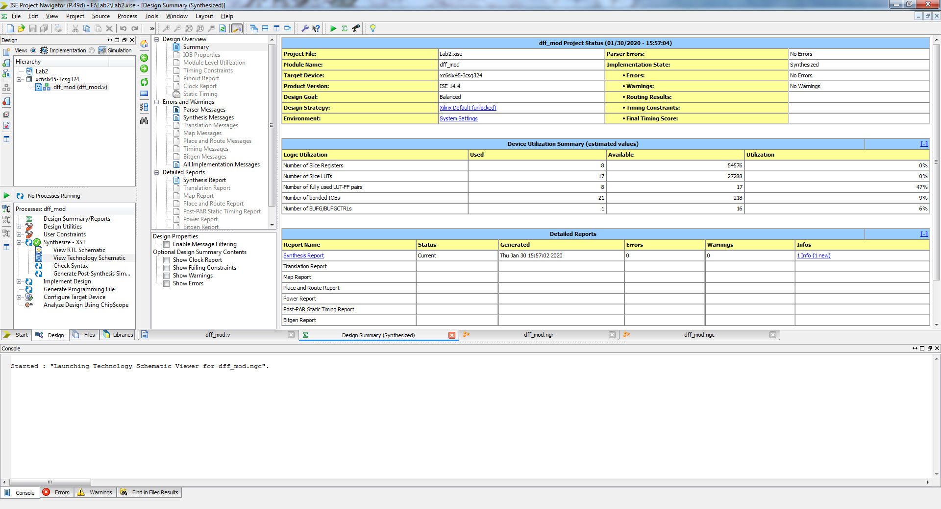

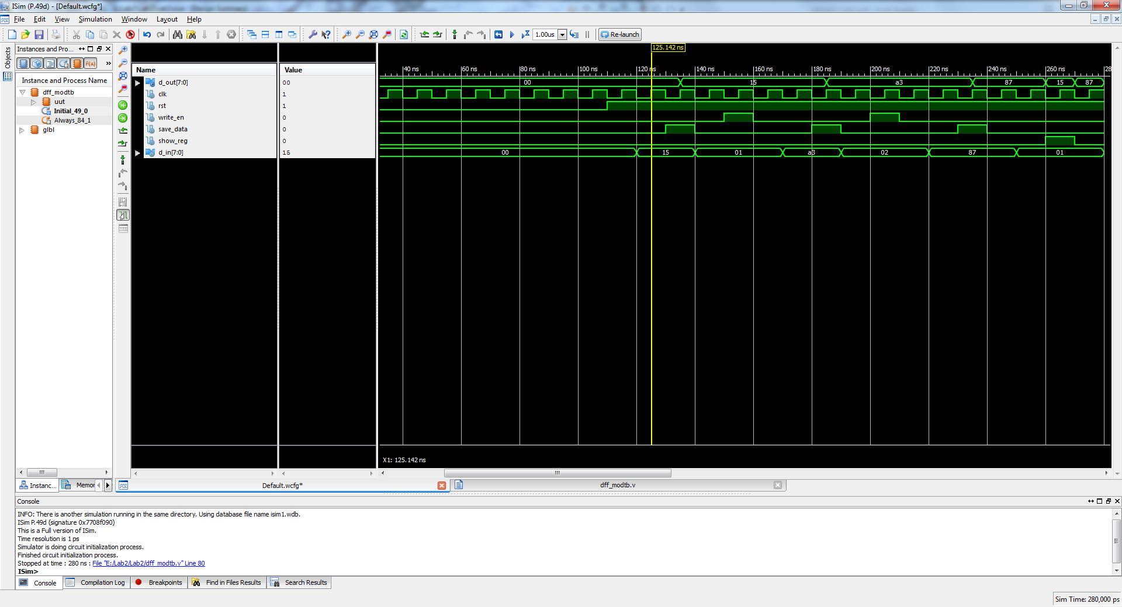

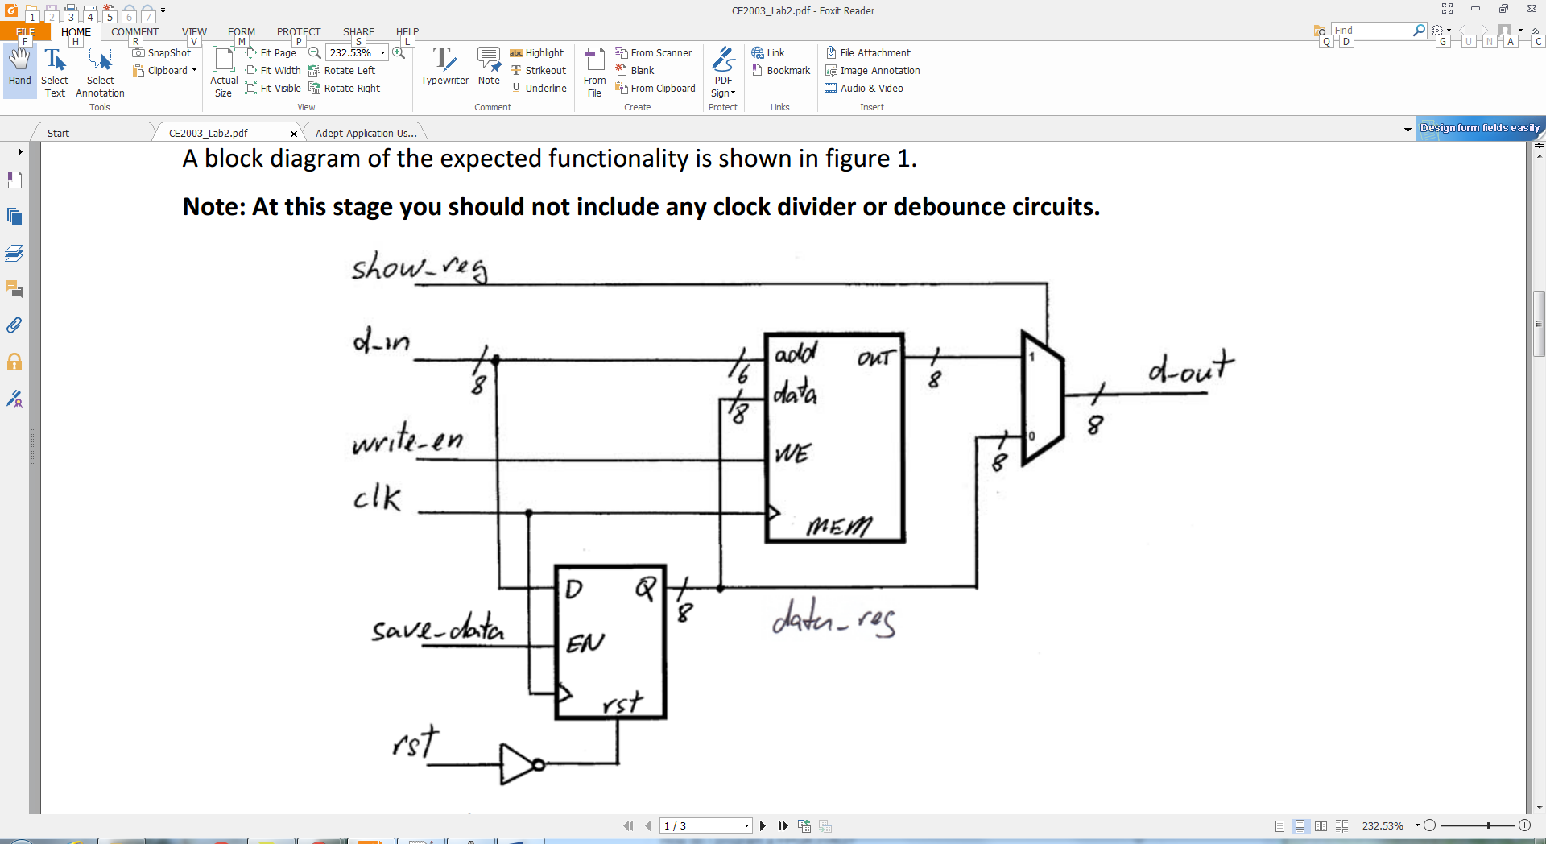

Expected Output

1. data go into D-flip flop (save _data - EN)-asserted to save the 8 bit width data
2. Saved data is available in D-flip flop to enable LUT module to save the data(from D flip-flop) into memory address on LUT (write_en-WE) asserted
3. (show_reg-MUX) to switch between data to display in LUT & D-flip flop